naturally matched: Business proposal
“know yourself.”
By:________

November 16, 2017

TABLE OF CONTENTS

INTRODUCTION
Purpose Statement…………………………………………………………………………..3
Problem History…………………………………………………………………………………
Product Solutions……………………………………………………………………………..4
PRODUCT ASSESTS
Features……………………………………………………………………………………………5
Future Development Goals………………………………………………………………..
MARKET ANALYSIS
Audience (Persona)…………………………………………………………………………..6
Competition………………………………………………………………………………………
What Sets Us Apart…………………………………………………………………………..7
APPENDIX
Chart Data…………………………………………………………………………………………8
Website Preview………………………………………………………………………………11

Purpose Statement
It’s no secret that African American men and women have been subjected to consistent oppression limiting our natural rights, opportunities, and even outwardly expression. While having straight hair was once seen as “superior,” many African American people have abandoned the Eurocentric ideals placed upon them and have begun to embrace their natural hair textures. People are looking for products and services that accentuate their features, not hide them. Naturally Matched strives to enhance the hair care experience by eliminating the uncertainty behind purchasing the “perfect” products at unusually high price points, allowing the consumer to focus on maintaining healthy hair journey. The purpose is to not only help people who are just starting out on their hair journey, but also people who want a chance at receiving quality products without having to sacrifice any monetary or moral values.

Natural Hair Challenges
African American men and women struggle with the hardships of finding products that work definitively for their hair type. Current hair care companies and distributors have tried to alleviate the increasing demand for products by simply generalizing African American hair care processes, but in doing this, they have lost the overall initiative of creating merchandise that represent the consumer. Most “big-brand” products currently on the market either don’t specify the hair type they cater towards or are too watered down to retain any moisture in the hair types. Additionally, many hair care companies don’t specialize in the products that they sell or don’t have black owners so the products aren’t made particularly for our benefit. Knowing that these brands are overpriced for a small amount of product sold (inadequate quality), large corporations are buying into the fact that people have to spend large amounts of money in order to figure out what works for them.

Product Solutions
With my product, Naturally Matched, I plan on creating a monthly subscription box that uses both scientific technology and natural hair care specialists (trichologists, etc. ) to match the customer against every product currently on the market to find the products that best fit their specific hair type. Allowing for the customer to send in 3 strands of hair (front, middle, and back of the head to cover all potential textures) to be tested and providing a customization tool that allows the consumer to request products that are currently apart of their hair care regime to incorporate into their box makes it easier to guide the consumer towards products that will benefit them the most.
I’ve incorporated the findings from my market research personas and created a product that eliminates excessive buying, promotes healthy hair, and combats against the current market pricing by providing your products within your monthly subscription box as well as offering the option to buy the products separately online at a lower price (due to some products running out faster than others.) Pairing you with your own personalized regime creates minimal fuss with having to figure out what products do what for your hair so you can shift your focus on creating a healthy hair lifestyle.
I will organize various styles of boxes to accommodate the consumer the best way possible; The price point will differ depending on how may products you decide to include in your box at one time; Also, I will offer a seasonal option for those who switch up their hair routines due to changes in the weather.

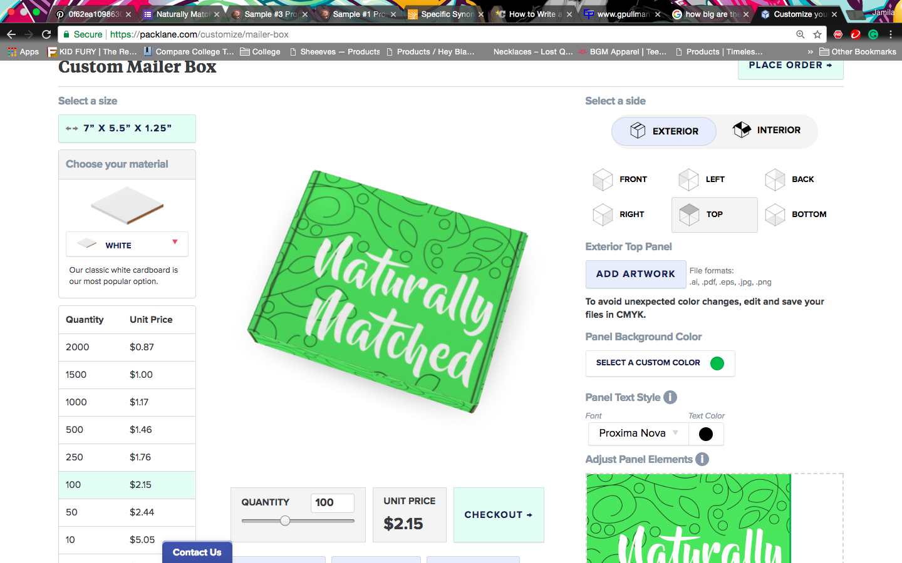
Features
- With the assistance of scientists and natural hair specialists, I will incorporate weekly, bi-weekly, and daily hair routines methods (Liquid, Oil, Conditioner (LOC), Liquid, Cream, Oil (LCO), Liquid, Oil, Cream, Oil (LOCO), Liquid, Oil, Cream, Sealant (LOCS), Protein Treatments, etc.) into a concise bundle of hair items to eliminate excessive buying.
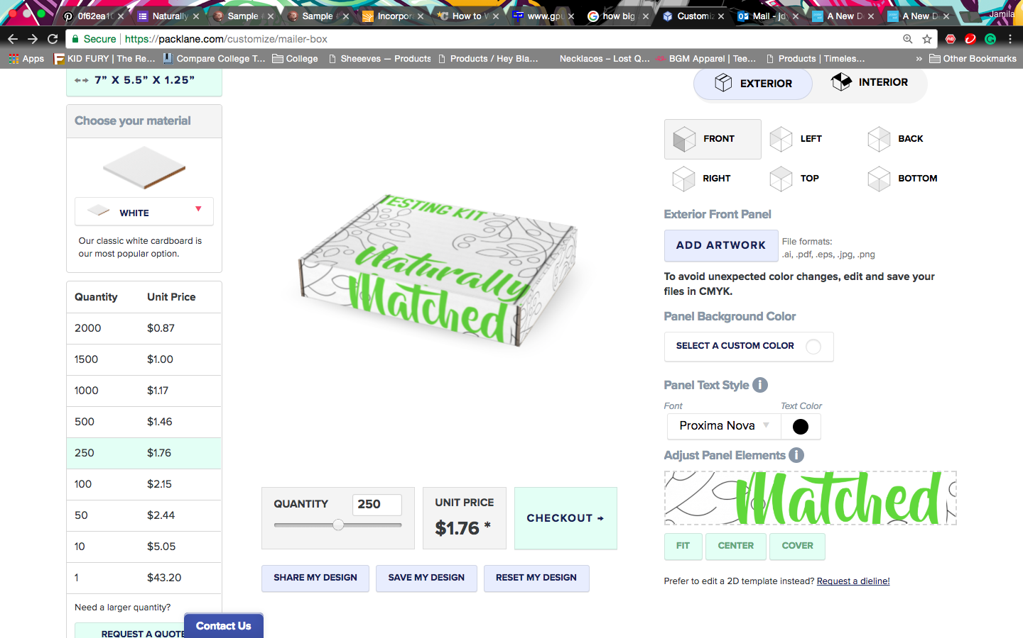
- Provides the option to purchase products separately and at a lower cost than sold in beauty supply stores or online with S&H costs (in the event that are product runs out before the others in the subscription box)
- Register hair kit online with unique identification ID/number to avoid any error in final results.
- During the process of purchasing my product, I will incorporate a secondary questionnaire to help get more background information on the customer to yield successful results. (Examples include: Assumed Hair Type, Assumed Porosity, Color-treated hair, Dry hair, Heat-damage, Thinning, Sensitive skin/scalp, etc.)
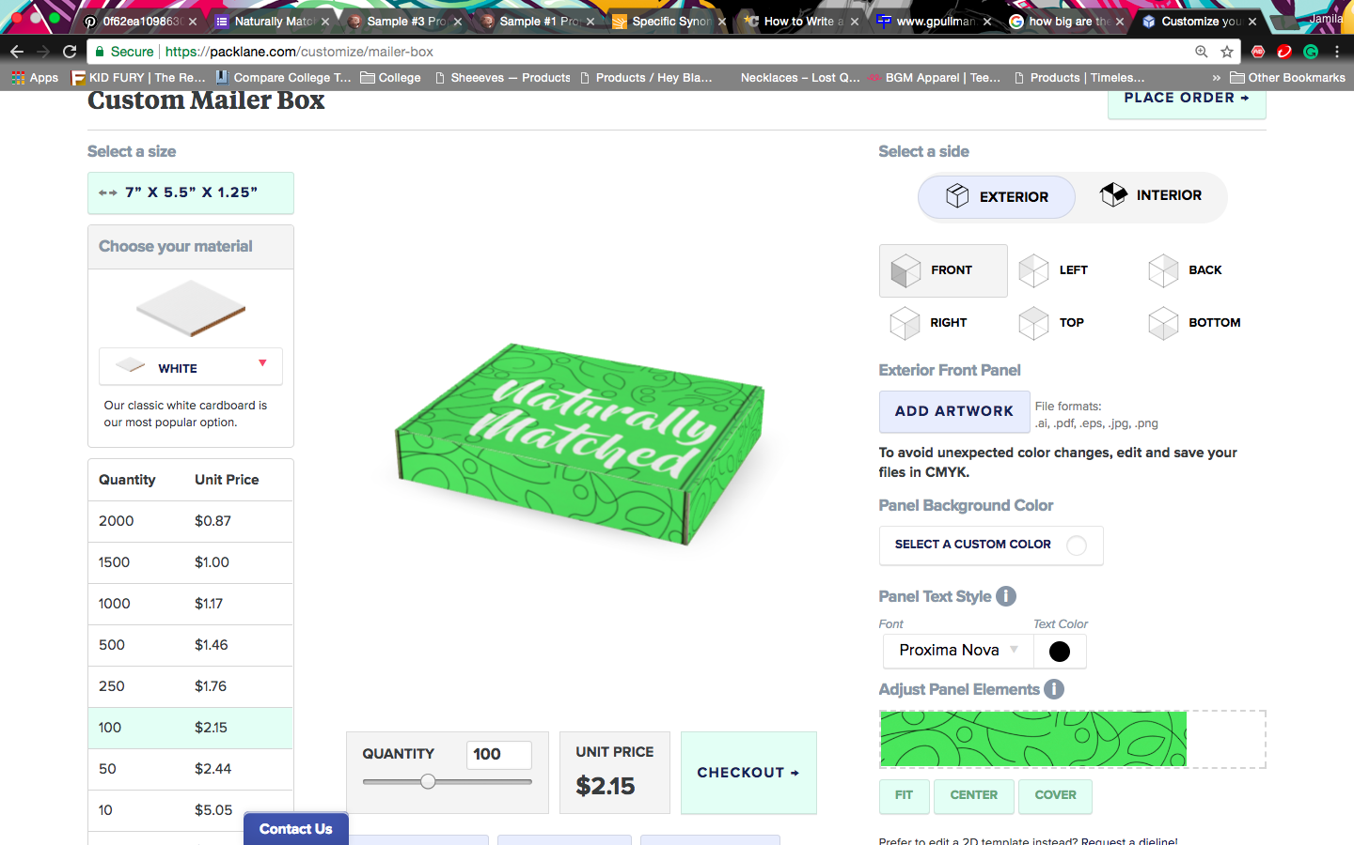
- Naturally Matched will integrate a free shipping label for the testing kits, a quick 1-2 week turn around for your results, and make sure to have a plethora of products to organize within your personal subscription box.

Future Development Goals
Naturally Matched is based on matching the customers with products that will best benefit their hair type at a reasonable price point. Because I would already be working with trichologists, I want to expand to providing a service that matches people with products that will encourage healthy edges (or products that will help you grow them out.) Also, while we’re still primarily online, I want to have a physical location in which people can go and get a face to face interaction with hair professionals ready to match them to products suitable for their individualized hair textures. With smaller versions of the machines used to process the locks of hair sent in online, our shops will be equipped with the tools necessary to make the process that much easier.
Audience (Persona)-
In gathering data through my questionnaire and speaking with people on an everyday basis, my potential clients and investors consist of people who understand the necessity of purchasing products that are made with the intent of providing you with the best results possible. People who are looking to find a system that encourages having and maintaining healthy hair without a lot of fuss at a price point that best reflects the market.
Competition-
Listed below are our competition which includes all hair care sites offering hair advice or selling their own products.
https://www.curlcentric.com/natural-hair-101/ , https://blacknaps.org/beginners-guide-natural-hair/, http://www.naturalhairrules.com/daily-moisture/, http://www.naturalhairgrowth101.com/routine-natural-hair-care.html), http://cantubeauty.com/, http://missjessies.com/, https://www.naturalhair.org/, http://www.asiamnaturally.com/faqs.html
Of course another form of competition would be our potential customers doing the porosity test at home and look up pictures that look similar to their own; people also use Youtube to look up consumer reviews of a product before they purchase it.
Yes, consumers at home can run porosity tests and look up videos of people that seemingly match their hair, but there is no guarantee of success in doing it on their own. Looking at pictures online can be misleading with variations in lighting and variables unknown to the consumer watching. I will enlist the help of scientists and natural hair specialists to make sure the most accurate information is given.
What Sets Us Apart
Tackling the idea of natural hair is a beast within itself; because there are so many obscure variables that could affect the outcome of a person’s hair (makes it difficult to pinpoint one remedy to a problem with multiple causes), most people want to only involve themselves with the products and not worry about the application afterwards. They settle with the “not everyone’s the same” idea and leave it, when they could treat it by taking the time out to look at each customer individually to assess their direct needs.

I wouldn’t be producing any products of my own, but rather analyzing the customer’s desires and using products that are currently on the market to organize them into a unique set that will work best for the customer. Additionally, partnering with the smaller companies to push their product would help them not only increase sales of their product, but improve a customer's attitude towards their product on the marketing end.

We take the time to understand the customer and their individual requests to produce a product that’s made personally for them.

Appendix
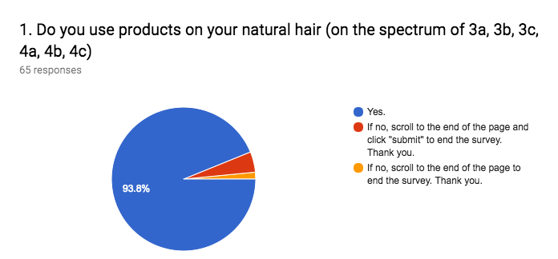
Included below are charts representing the marketing environment for my Naturally Matched product. I included a mix of structured questions to receive distinct answers as well as open-ended questions to represent the consumer in their fullest form. I’ve also included a preview of our website where our services can be accessed and purchased.

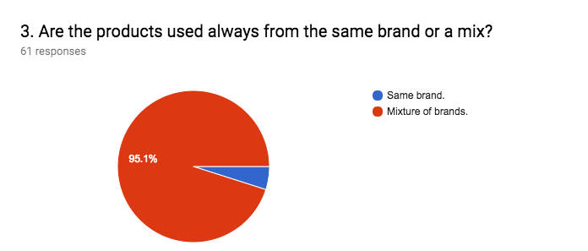

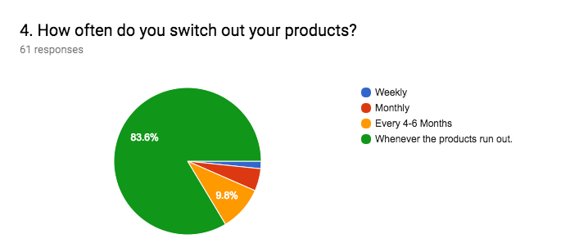

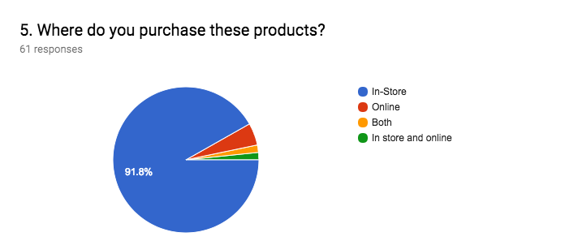

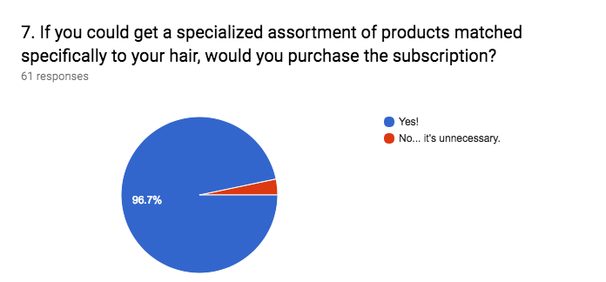

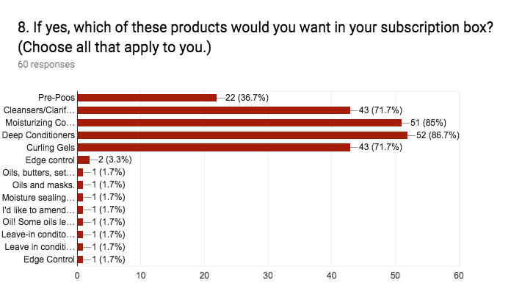

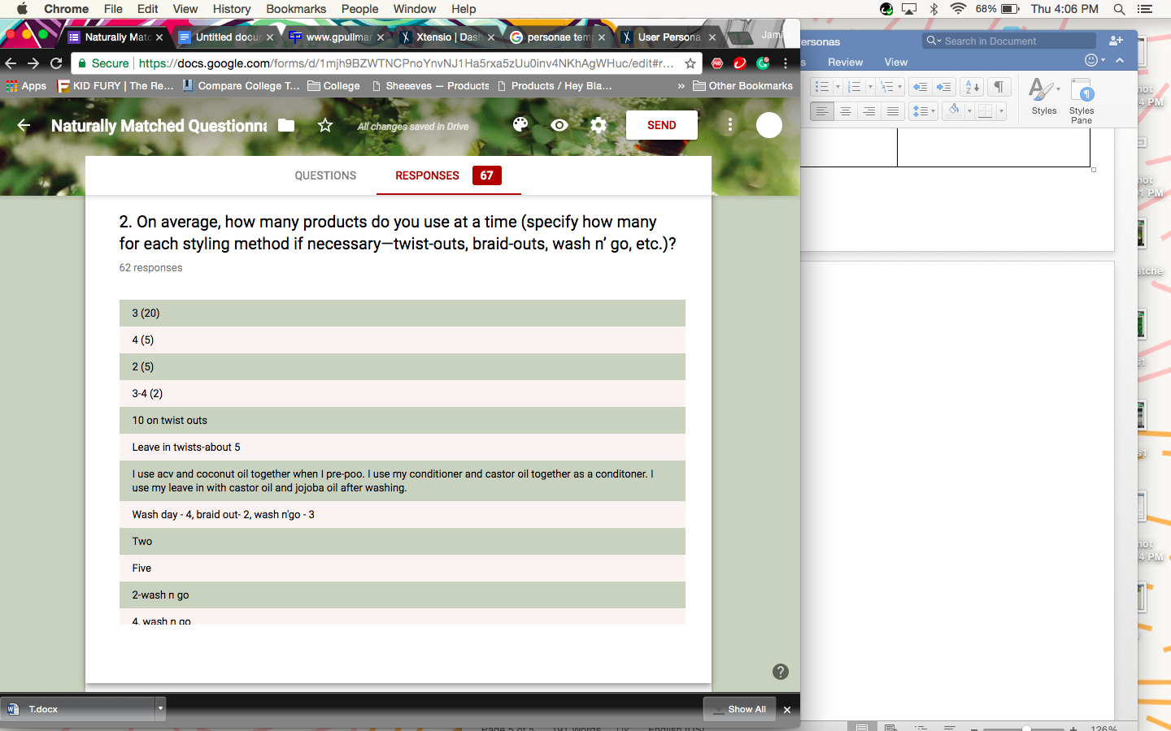

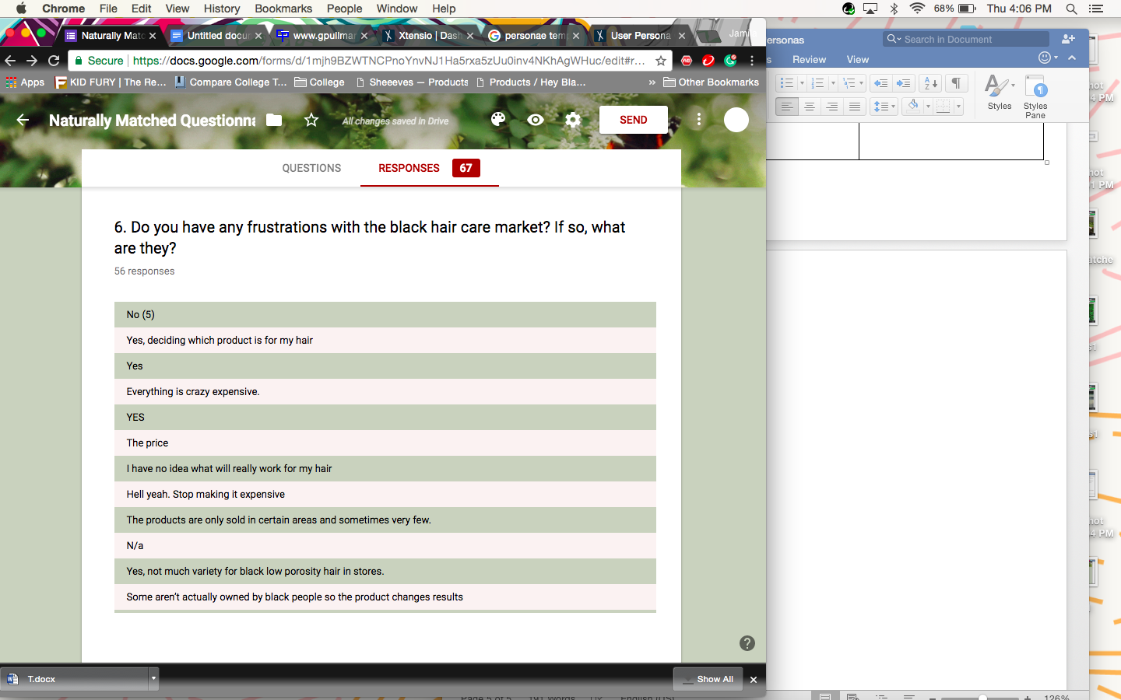

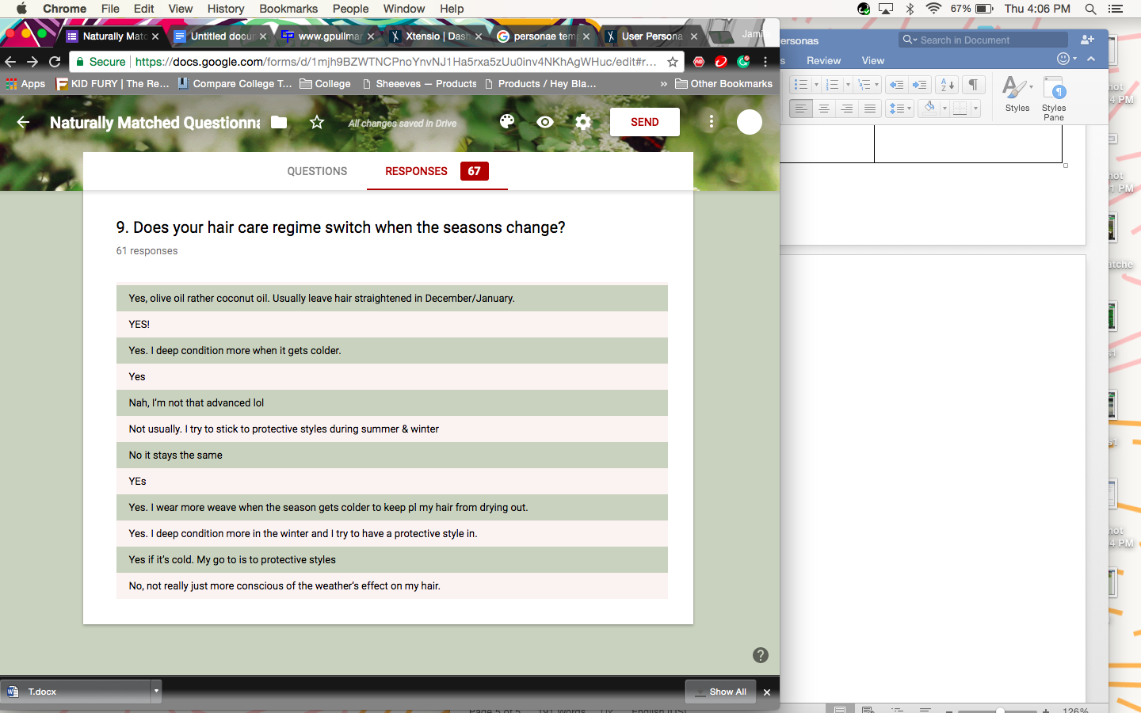

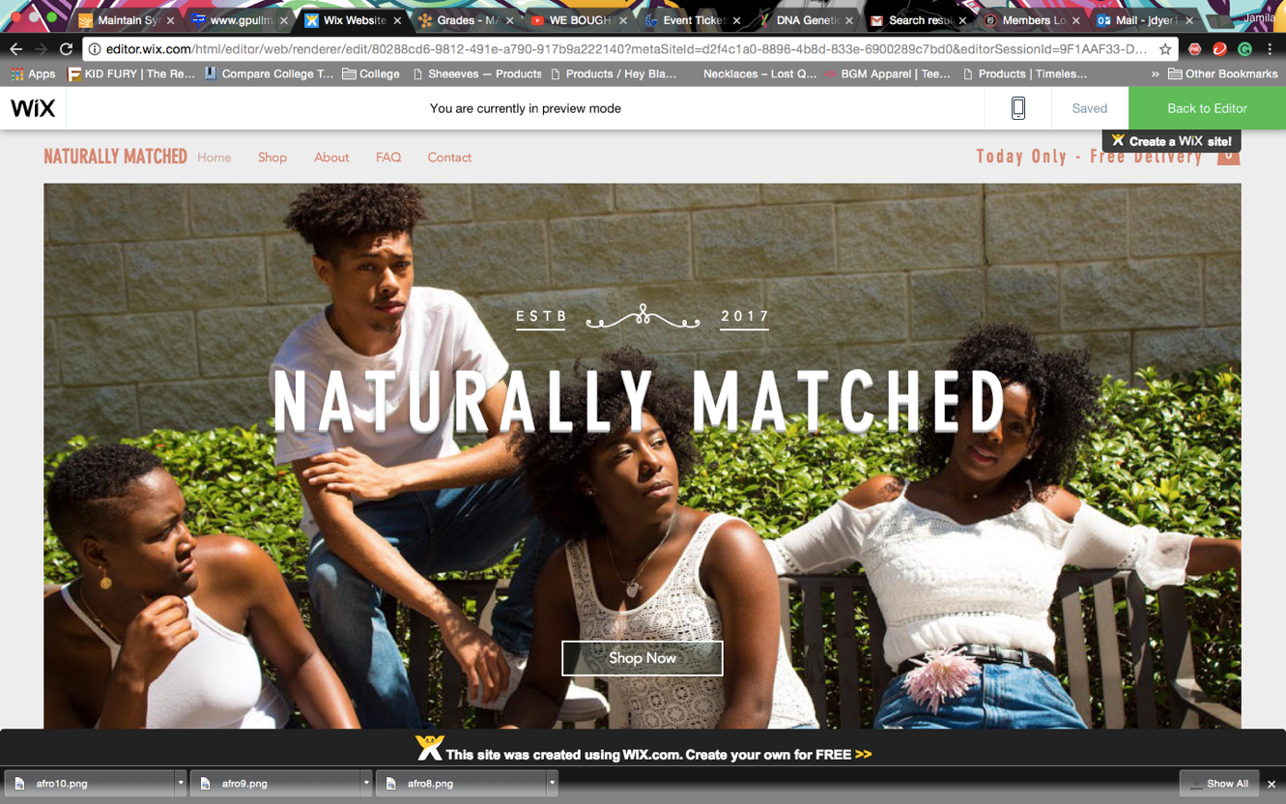
Website Preview:
